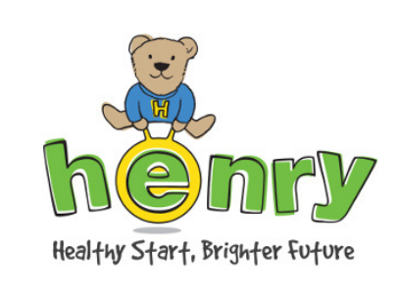
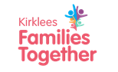
Kirklees Council
Family Support Service
Learning and Early Support
PO BOX 1720
Huddersfield
HD1 9EL

Tel: 01484 221000

Hi

Thanks for signing up for the Henry Workshop(s) at Slaithwaite Library

Each workshop will last for 90 minutes and will be held in the training room (through the back of the library) on Thursday mornings from 10am to 11.30am

The workshops you’ve booked are as follows:

Eat Well for Less 6th November

Fussy Eaters 13th November

Healthy Teeth 20th November

Let’s Get Active 27th November

Looking after Ourselves 4th December

Understanding Children’s Behaviour 11th December

If for any reason you’re unable to attend, (or if you decide you’d like to join additional workshops) please email or text to let us know

We look forward to meeting you

Anita– anita.wilkinson@kirklees.gov.uk Tel: 07814 185650

Gill – gill.simpson@kirklees.gov.uk Tel: 07807 123527

