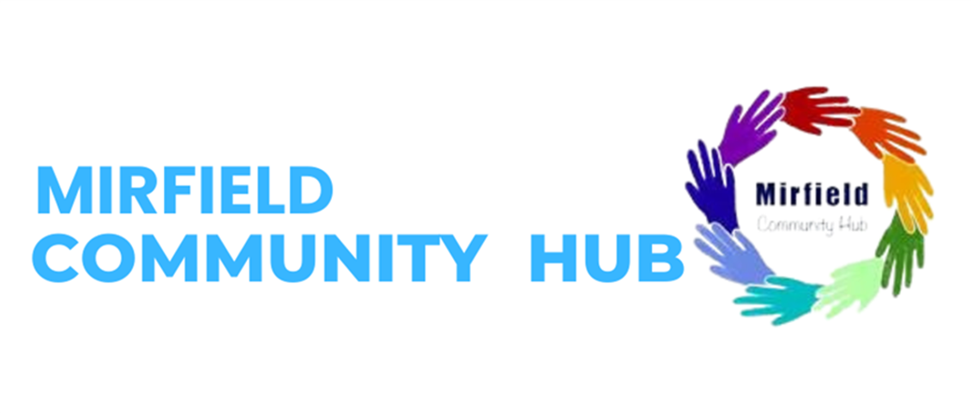

**Easter Family Fun events at Mirfield Community Centre.**

**The Mirfield Community Hub along with Kirklees College and partner agencies are pleased to announce free family fun activity sessions.**

To ensure the safety of all attendees, we kindly ask families to book the session in advance.

Wednesday 9th April 1:30-3:30pm

<https://www.eventbrite.co.uk/e/easter-family-events-tickets-1283980824209?aff=oddtdtcreator>

Wednesday 16th April 1:30-3:30pm

<https://www.eventbrite.co.uk/e/easter-family-activities-tickets-1283987855239?aff=oddtdtcreator>

Come and join us for free family fun events including:

Easter arts and crafts session with Kirklees college- please bring ID if you would like to participate in this, Kirklees Keep in Mind will be in attendance making wellbeing activities with children.

Further information email [claire.nellen@kirklees.gov.uk](mailto:claire.nellen@kirklees.gov.uk)

Refreshments provided for children and parents/carers.

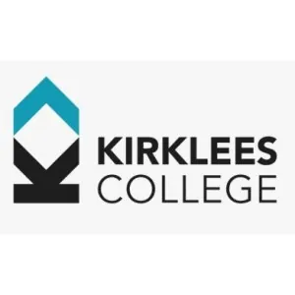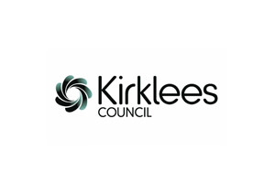

If you wish to take part in the craft activities

Please could you bring the following to enrol with Kirklees College, this ensures that the activities

For the craft activities delivered by college to remain free of charge.

You will need to bring the following information with you:

• Proof of address

• National Insurance Number

• Photo ID

• Passport

• Residence Card

• Visa Spouse/Dependent/Joining Family Member - Biometric Residence Permit and passport, partner or family members passport and Biometric Residence Permit, marriage certificate, birth certificate

• Proof of current Asylum status (letter) and ARC card

• Section 95 proof

• Proof of benefits or Access to Universal Credit app on

This ensures that we can offer the course free of charge.